EE 464 – Power Static Conversion II

Project 2

Berk Zorlutuna
Talgat Buzurkanov

Instructor: Ozan Keysan

17.04.2018
Introduction:
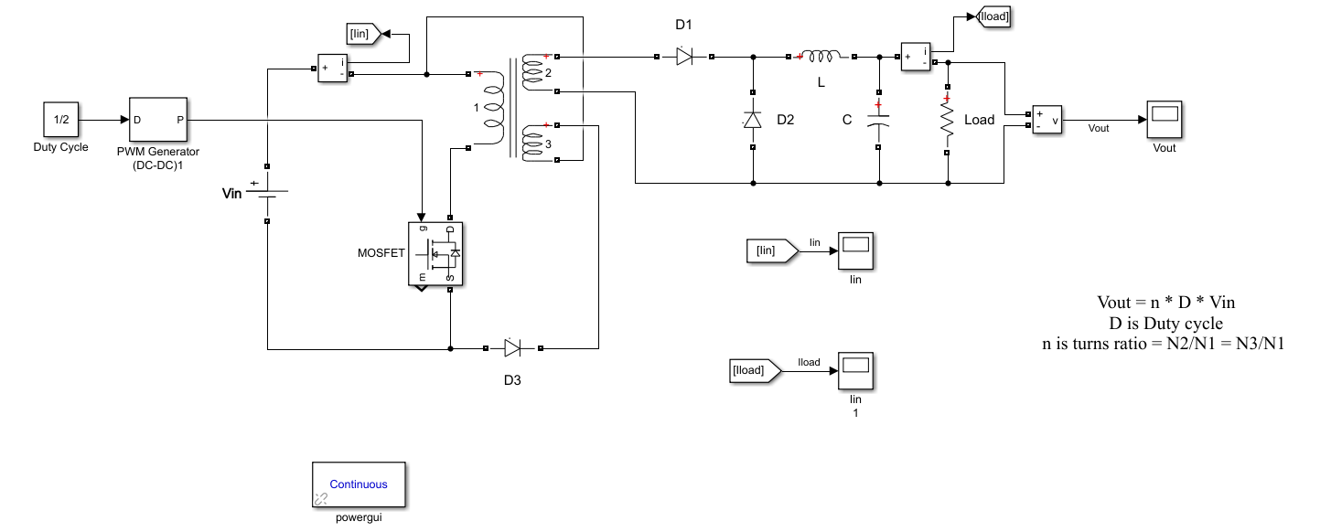
In the second project of EE 464 Power Static Conversion course, our purpose has been to design a forward controller which is supposed to convert 24 volts DC to 12 volts DC. For this purpose, we have implemented a non-ideal MOSFET and a pulse generator in order to drive our circuit. Then, a three winding transformer in order to sustain the isolation between input and output sides to the converter. Just before the output end of the converter, an LC low-pass filter has been implemented, so that voltage ripples on the load would be minimized.

Figure 1: Forward converter schematic
Isolated converter simulation:
Since our purpose is to convert 24 volts DC to 12 volts DC, by using the following formula,
Vout = n * D * Vin
D is Duty cycle
n is turns ratio = N2/N1 = N3/N1
We have chosen:
D = 0.5
N1 = N2 = N3
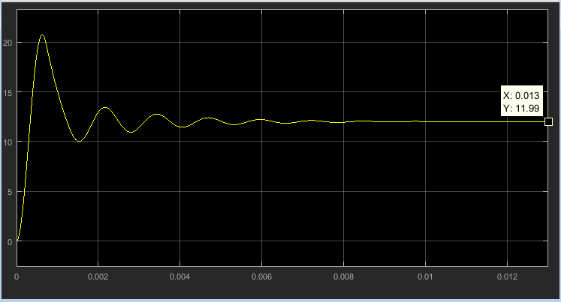

Figure 2: Output voltage load impedance is 10 ohms

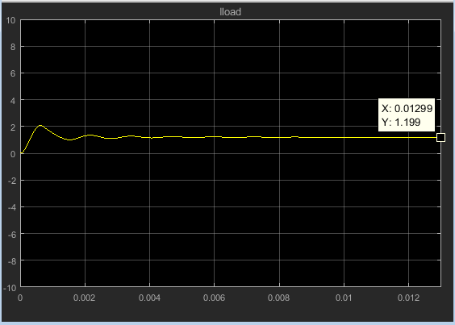
Figure 3: Output current when load impedance is 10 ohms

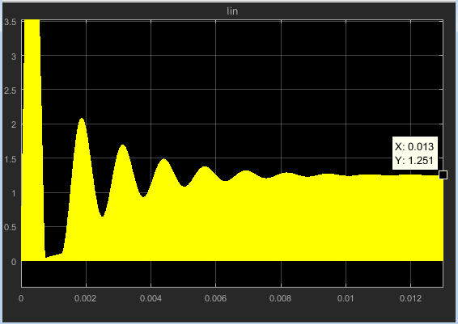
Figure 4: Input current

